

**A REPORT ON THE ONGOING BLACK SOLDIER FLY LARVAE BASED FISH FEED PROJECT AT KMFRI SAGANA**

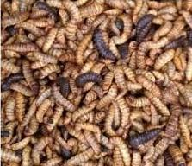

**PROJECT TITLE:**

**Validating Insect-Based Protein-Rich Feeds for Enhanced Nutrition and Health of Fish in Kenya**

**SUBMITTED BY:**

**Dr Jonathan Munguti, (PI - KMFRI)**

**September, 2022**

**SUMMARY**

Aquaculture in Kenya has grown rapidly over the last decade and plays a majorly important role in the national supply of fish from capture fisheries with freshwater fisheries accounting for about 98% of Kenya’s reported aquaculture production as per Kenya’s Aquaculture Brief, 2017. This rapid growth has in turn necessitated the high demand of quality fish seed for the commonly cultured fish species; Nile tilapia and African catfish (Ngugi and Manyala 2004) with Tilapia production contributing to about 90% of aquaculture production in Kenya. Due to this expansion of the Kenyan aquaculture sector, there has been a rapid shift from extensive methods to semi-intensive and intensive methods of fish culture and as such a need to justify the high aquaculture output likely to compromise fish feed quality against fish feed ingredients and formulation.

Fishmeal and fish oil being recognized as nutritionally balanced and preferred protein and lipid sources in aquafeeds for finfish farming. However, the limited supply, soaring prices, and depletion of wild capture fisheries have prompted the aquaculture industry to look for widely available and less expensive alternatives for fishmeal and fish oil to ensure the sustainability of aquaculture production. As an alternative to fishmeal protein and oil, black soldier fly (BSF) larvae are considered a promising candidate for its high protein, lipid and minerals content, as well as for its bioactive potential with anti-microbial, anti-fungal, and anti-viral functions.

Using black soldier fly larvae meal (BSFM) in place of fishmeal is an ingenious strategy for sustainable fish aquaculture. Therefore, this 6-month study will investigate the effect of partially replacing fishmeal with BSFM on feed utilization and growth performance of grow out Nile tilapia fish. Four diets were formulated by replacing fish meal diet with BSFM diet at the rate of T0 (BSF 0) T25 (25%BSF) T50 (50%BSF) and T75 (BSF 100%BSF).

While considering alternative fish feeds, several factors should be analyzed to ensure their technical, economic and social viability. The technical aspects are related to the protein content, nutritional quality of proteins, the presence of anti-nutritional factors and digestibility by fish among others that affect the physical growth of fish. The Kenya Climate Smart Agriculture Project (KCSAP), a Government of Kenya project jointly funded by the World Bank is geared towards improving the fish feed sector to ensure the industry continues to improve the livelihoods of the communities through provision of quality and quantity fish feeds. In an effort towards meeting the high-quality fish feed demand, a BSFL-Based fish feed project is being carried out at KMFRI Sagana centre. This report documents the milestones that have been reached in the experiments that are ongoing at the research centre.

**1.0 INTRODUCTION**

The supply of fisheries products has become unsustainable due to a decline in capture fisheries production and an increase in global demand for fish. In recent years, efforts have been made to promote aquaculture as a means of meeting food demand (Nyonje et al., 2018), as it is considered as a viable alternative to relying on wild fish stocks (Friend and Funge-Smith, 2012). Aquaculture has grown from relatively low levels in the previous five decades to be comparable to catch fisheries in terms of world food output (Ogello et al., 2014). Developing countries dominate aquaculture production, with roughly 90% of total aquaculture production coming from Low Income Food Deficit Countries (FAO, 2013a). Despite rich and diverse natural resources, aquaculture production in most African developing countries remains inadequate (FAO, 2010).

Aquaculture totally depends upon the provision of nutrients as in other terrestrial farming practices. Diets with proper nutrient balance are important in enhancing fish health and higher fish production (Bandara, 2018). One of the main bottlenecks in boosting aquaculture in Kenya is inadequate availability of quality and affordable aqua-feeds. Fish feeds take up between 40-60% of the fish farm’s production costs and is a major constraint to fish farming in resource poor regions. Feed is therefore pertinent to the success of aquaculture development. Commercial fish feeds are, when available, expensive and beyond reach of most rural sub-Saharan Africa fish farmers who mostly live on less than a dollar a day (Charo-Karisa et al., 2013). Aquaculture therefore can no longer depend on the fish meal (FM) as the main protein source because of its fluctuating supply and increasing price trend (Muin et al., 2017).

A key aspect of the aquaculture industry sustainability is the supply of proteins for aquafeeds as fish meal (FM) is a finite resource. While considering alternative fish feeds, several factors should be analyzed to ensure their technical, economic and social viability. The technical aspects are related to the protein content, nutritional quality of proteins, the presence of anti-nutritional factors and digestibility by fish among others that affect the physical growth of fish.

Recently the interest of researchers about insect meals has increased, and studies have highlighted that they can successfully be used in fish diets (Barroso *et al.,* 2014; Henry *et al., 2015*). Insects are promising sources of protein and lipid in feeds for farmed animals. Many fish species feed on insects, so the use of insects as food in aquaculture comes naturally but their contribution to household fish production is insignificant (Govorushko, 2019). According to Sánchez-Muros *et al.,* (2014), there are around one million known species of insects and only 20% have been named and described showing the variety and the potential that these ingredients can have to replace fish meal, Recently, the European Commission allowed the use of insect meals in aquafeed [Reg. (EU) 2017/893] uplifting the feed ban regarding the use of insect-derived processed animal proteins (PAPs) for farmed fish (Tan *et al.,* 2018). The Regulation indicates the seven authorized insect species [black soldier fly (BSF), *Hermetia illucens*; common housefly (HF), *Musca domestica*; yellow mealworm (MW), *Tenebrio molitor*; lesser mealworm, *Alphitobius diaperinus*; house cricket, *Acheta domesticus*; banded cricket, *Gryllodes sigillatus*; field cricket, *Gryllus assimilis*)], and defines the allowed rearing substrates to grow insects on (Gasco *et al.,* 2020; Madau *et al.,* 2020).

Research on the use of insect meal (IM) in aquafeeds has developed rapidly in the last years, leading to an increased number of scientific contributions on this topic recently. Previous studies have highlighted that insect-based protein meals can be used as a more sustainable alternative to conventional protein (fish or plant protein meals) used in aquaculture (Gasco et al., 2016; Henry et al., 2015). Insects possess an outstanding capacity to upgrade low-quality organic material, require minimal water and cultivable land, and emit little greenhouse gases (van Huis, 2013). The shift to an insect-based feed offers circular economy opportunities and thus enhances environmental cleanup services by recycling biowaste and greenhouse gas emissions (Ermolaev *et al.,* 2019; Mertenat *et al.,* 2019). The use of insects as feed source is known to reduce economic and environmental costs because they can be fed by-products (Sealey *et al.,* 2011) and require little infrastructure or resources. Insect meals are very well suited for a feed application due to their high nutritional value and indicate to have a low water footprint as well as low land requirements (Tschirner and Kloas, 2017; Surendra *et al.,* 2016; Makkar, 2017). Insect meal is also a highly environmentally friendly source of nutrients, in accordance with Goal 14 of the Sustainable Development Goals. The new insect sector provides animal protein through a sustainable production process with low-value inputs, high-value outputs and low environmental impact and can become an important element of the circular economy (Dicke, 2018).

As part of its support to the promotion of fish culture in Kenya, the KMFRI Sagana centre provides empirical-based research outcomes to stakeholders in the aquaculture sector. Several research activities in the fields of fisheries and aquaculture are being carried out at the centre. The centre intends to improve training and increase fish feed production for adoption by local farmers and other stakeholders. The BSFL feed experiment is carried out at the centre as part of the KCSAP project to achieve this. The study therefore intends to investigated the effects of partial substitution of fishmeal protein with partially defatted BSF larvae protein on growth performance of Nile tilapia.

**2.0 MATERIAL AND METHODS**

**2.1 EXPERIMENTAL DIETS**

Four different treatments were formulated and prepared with approximately 30% Crude protein including FM (fish meal) based diet that served as the control. The ingredients and chemical composition of formulated diets are shown in table 1 below. The dietary treatments were prepared and mixed at the KMFRI Sagana store as previously directed by project investigator. Briefly, the powdered fish meal was mixed with pre-weighed quantities of BSFM and other ingredients in pre-determined quantities as described in the table. The mixed diets were then subjected to sun for drying after which they were milled to achieve a powdered like diet for ease of pelleting. Required feed quantity was weighed and water added to make the treatment produce a dough like mixture for ease of pelleting. Different treatments followed the same procedure as pelleting was then done by a pelletizing machine. The diets were pelleted at 3mm each given the size of the experimental fish.

**Dietary formulation and processing**

The BSFLM Based diet was formulated prior to feeding. Fish feed ingredients used to prepare feeding treatment are as follows;

1. Wheat pollard
2. Rice polishing
3. Maize germ
4. Fish meal
5. BSFLM
6. Soya bean meal
7. Lysine
8. Methionine
9. Fish premix.

**Figure 1. Mixing and sun-drying experimental ingredients at KMFRI Sagana**

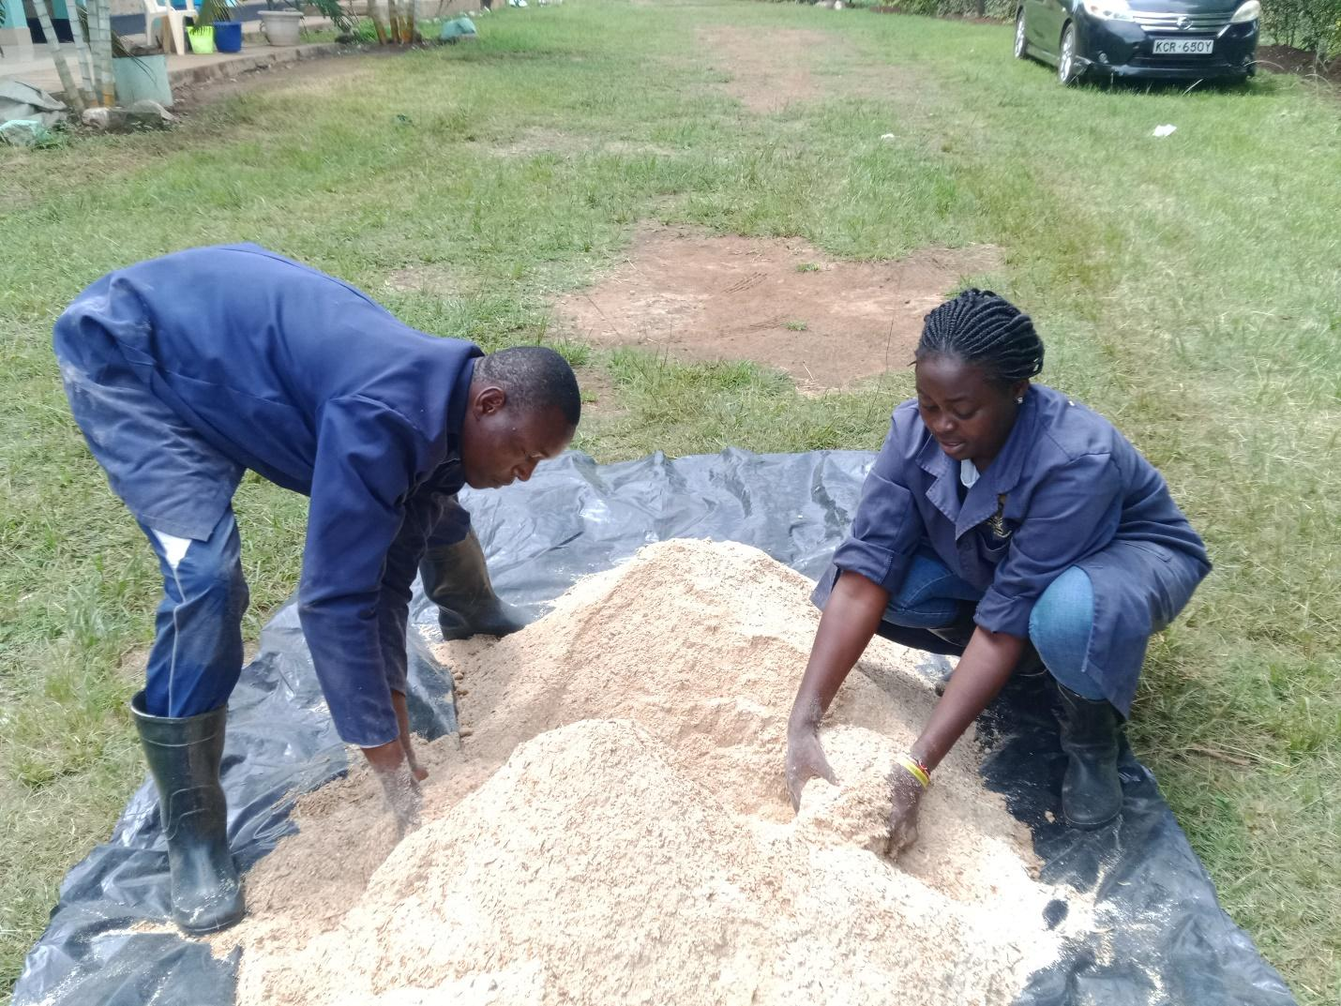

**Table 1. Ingredients and nutritional composition of experimental diets fed to tilapia grower/Finishing Diets**

|  |  |  |  |  |  |
| --- | --- | --- | --- | --- | --- |
| **Ingredient** | **T0** | **T25** | **T50** | **T75** |  |
| Pollard | 7.00 | 7.00 | 7.00 | 7.00 |  |
| Rice Polishing | 20.00 | 19.25 | 19.00 | 18.75 |  |
| Maize germ | 22.00 | 22.00 | 21.50 | 21.00 |  |
| Fish meal | 7.00 | 5.25 | 3.50 | 1.75 |  |
| BSFLM | - | 2.50 | 5.00 | 7.50 |  |
| Soybean Meal | 35.00 | 35.00 | 35.00 | 35.00 |  |
| Sunflower Cake | 5.00 | 5.00 | 5.00 | 5.00 |  |
| Lysine | 1.00 | 1.00 | 1.00 | 1.00 |  |
| Methionine | 1.00 | 1.00 | 1.00 | 1.00 |  |
| Fish Premix | 2.00 | 2.00 | 2.00 | 2.00 |  |
| TOTAL | 100.00 | 100.00 | 100.00 | 100.00 |  |
| **Nutrient Level** |  |  |  |  |  |
| **CP** | 30.60 | 30.52 | 30.42 | 30.32 |  |
| **Energy** | 3,037.21 | 3,049.11 | 3,049.95 | 3,050.80 |  |

* 1. **Experimental system set-up and components**

The study on use of BSF as an alternative fish feed and fish protein source was conducted at KMFRI Sagana research ponds in pond no D4. The pond measures 24 by 18 meters and 3 feet in depth. The experimental system set-up entailed 12 cages installed and labeled with tags as **cage 1…to** **cage 12.** Each cage measuring 2.5 by 2m. The system design is random block headed with the treatments randomly distributed in the cages. The set-up allows for continuous flow of water in and out of the pond. This in turn helps maintain the water temperature and dissolved oxygen quantities at 25oc and 5.5-6mg/l. Other water quality multiparameter were tested on a weekly basis to maintain fish health, prevent mortalities and maintain fish aggressiveness and response to feeding.

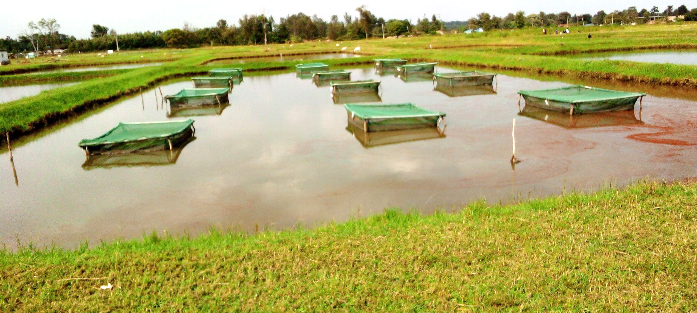

* 1. **Transportation and acclimatization of experimental fish**

The experimental fish were obtained from S-ponds, sampled with an average individual weight of 25 ± 5 g per fish. The fish were randomly and evenly distributed to the experimental cages for two weeks of acclimation prior to trial commencement, at a stocking density of 30 fish per cage. During the acclimation period, fish were fed on 2mm commercial diets obtained from Fugo feeds after which the fish were sampled to determine their individual body weight and length. The experimental fish were subjected to formulated dietary diets Experimental diets were fed randomly to triplicate groups of fish to satiation and feeding was done twice daily, in the morning at 10:00 am and evening 4:00 pm throughout the experimental period (6months)

An initial sampling was done on the fingerlings before stocking where individual fish body weights were measured. This was done to guide the feeding rates, as fish is fed depending on its body weight

**Table 2. Average initial weights of fish and feeding quantities per cage**

|  |  |  |  |  |  |
| --- | --- | --- | --- | --- | --- |
| Cage | No. of Fish | Average wt. (g) | Feeding rate (3% BW) | Feeding quantity (g) | Feeding ration (g) |
| **C 1** | 30 | 24.81 | 0.03 | 22.329 | 11.1645 |
| **C2** | 30 | 25.69 | 0.03 | 23.121 | 11.5605 |
| **C3** | 30 | 25.42 | 0.03 | 22.878 | 11.439 |
| **C 4** | 30 | 22.73 | 0.03 | 20.457 | 10.2285 |
| **C 5** | 30 | 24.63 | 0.03 | 22.167 | 11.0835 |
| **C 6** | 30 | 25.44 | 0.03 | 22.896 | 11.448 |
| **C 7** | 30 | 24.14 | 0.03 | 21.726 | 10.863 |
| **C 8** | 30 | 24.23 | 0.03 | 21.807 | 10.9035 |
| **C9** | 30 | 24.8 | 0.03 | 22.32 | 11.16 |
| **C10** | 30 | 25.36 | 0.03 | 22.824 | 11.412 |
| **C11** | 30 | 24.67 | 0.03 | 22.203 | 11.1015 |
| **C 12** | 30 | 25.24 | 0.03 | 22.716 | 11.358 |

* 1. **Feeding strategy and sampling techniques**

The study sampling was employed as follows: Experimental fish were sampled after every 21 days of feeding to determine the overall performance of individual fish body weight and length. Each dietary treatment was allocated to 3 different cages and fish hand fed at the rate of 3%-4% body weight per day- a rate that is sufficient for grow out. To ensure that there is no refusal after feeding, the cages are made with nets that allow passage of refuse.

The daily ration was split to 10:00hrs and 15:00hrs feeding sessions. Due to high photophobia tendencies and cannibalistic nature of the Nile tilapia, the experimental fish were not subjected to direct sunlight to prevent the problem. Because fish were handled by bare hands during sampling, potassium permanganate was used to disinfect the fish to prevent spread of diseases and kill pathogens that would be present. Sampled fish were then returned in their respective cages after sampling. Feed Conversion Ratio (FCR) was then calculated based on feed intake and weight gained of the fish during the feeding period with the following formular;

$FCR=\frac{Feed intake\left(g\right)}{weight gained\left(g\right)}$

Water quality parameters were also sampled on a weekly basis and when carrying out fish sampling. This would help identify the concentration of different parameters measured and if they affect the outcome of the results during fish sampling. Feed offered was adjusted at the end of evry sampling period to determine the quantity fed per day per treatment.

**Table 3. Result of water quality sampling on dates 9th August 2022**

|  |  |  |
| --- | --- | --- |
| **Parameter** | **Inlet** | **Outlet** |
| Temperature | 19.0 | 19.4 |
| D.O | 8.35 | 7.60 |
| PH | 7.4 | 6.9 |
| TDS | 56.5 | 55.25 |
| SAL | 0.03 | 0.03 |
| COND | 89.0 | 88.3 |

**figure 2. Fish sampling on experimental fish at KMFRI Sagana research pond.**

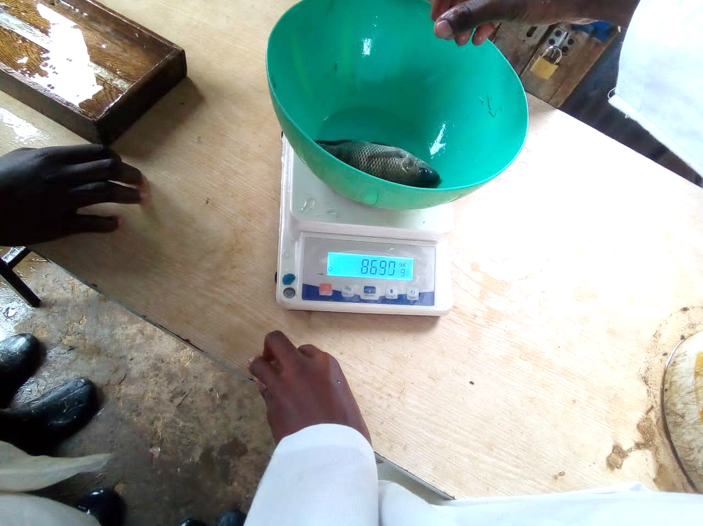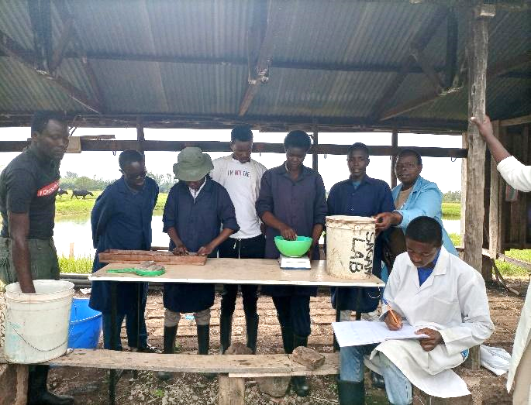

1. **Data analysis.**

Measurement from multiple fish per cage per treatment were averaged on every sampling day before analysis such that each replicate cage had one figure. R-studio statistical software was used to run the data that was collected for the entire sampling period. Data from all measured parameters were evaluated to test for significance. This was aided by a post hoc analysis where it was easy to know the difference in treatments across the sampling period. The length-weight relationship among fish was also determined to help understand the type of growth that was exhibited by the experimental fish. The growth can either be isometric or allometric. An Isometric type of growth, refers to increase in body length and girth at the same rate or proportion. Isometric growth is considered when the Length coefficient of growth is equal to 3. When that coefficient is greater than 3, the growth is referred to as positive allometric growth while when the length coefficient is less than 3 the growth is considered to be negative allometric growth. Allometric growth is referred when the elongation of the body trunk exceeds that of the body girth or vice versa.

**4.0 RESULTS AND DISCUSSION**

**General Increase in Length and Weight**

The mean weight and length increased over the sampling period as the feeding was done. The weight increased by 2 grams in every subsequent sampling while the length increased 0.1 cm in every subsequent sampling. The initial weight recorded was 59 grams while the final weight recorded was 72 grams thus registering a mean increase of 13 grams along the sampling periods and treatments. The average initial length recorded was 14.69 cm while the final average length was 15.76 cm thus registering an average of 1.07 cm.

| **Variable** | **2022-05-27** | **2022-06-17** | **2022-07-08** | **2022-07-29** | **2022-08-19** | **2022-09-09** | **2022-09-30** |
| --- | --- | --- | --- | --- | --- | --- | --- |
| WEIGHT | 59 ± 17 | 61 ± 16 | 63 ± 18 | 66 ± 18 | 68 ± 19 | 71 ± 21 | 72 ± 23 |
| LENGTH | 14.69 ± 1.3 | 14.77 ± 1.2 | 14.90 ± 1.4 | 15.34 ± 1.3 | 15.56 ± 1.4 | 15.66 ± 1.5 | 15.76 ± 1.8 |

**Length and Weight Change over Sampling Period across Treatments**

Treatment 50 registered the highest final mean weight of 74.8 grams, followed by T25 with 74.20 grams, then T0 with 69.7 grams while T75 had the least mean weight of 69.4 grams. The data indicate that T50 had the highest mean weight gain of 16.1 grams followed by T75 with 12.7 grams, T25 with 12.1 grams and finally T0 had the least mean weight increment of 11.3 grams.

| **Treatment** | **2022-05-27** | **2022-06-17** | **2022-07-08** | **2022-07-29** | **2022-08-19** | **2022-09-09** | **2022-09-30** |
| --- | --- | --- | --- | --- | --- | --- | --- |
| WEIGHT T0 | 58.44222 | 60.22222 | 61.99111 | 64.38372 | 66.24581 | 71.04977 | 69.72898 |
| WEIGHT T25 | 62.00444 | 63.73333 | 66.82222 | 69.12500 | 71.57678 | 73.43345 | 74.20023 |
| WEIGHT T50 | 58.73556 | 60.94444 | 62.98556 | 66.27778 | 68.81425 | 73.52449 | 74.79236 |
| WEIGHT T75 | 55.69333 | 59.11889 | 61.49444 | 63.96629 | 65.78230 | 67.64091 | 68.40379 |

Treatment labelled T25 had the highest final mean length of 15.97 cm followed by T50 with 15.88, then T0 with 15.60 while T75 had the least mean length of 15.55. T50 had the highest mean length increment of 1.16 cm followed by T75 with 1.15 cm, then followed by T25 with a mean length increment of 0.98 cm, followed by T0 with 0.94 cm.

| **Treatment** | **2022-05-27** | **2022-06-17** | **2022-07-08** | **2022-07-29** | **2022-08-19** | **2022-09-09** | **2022-09-30** |
| --- | --- | --- | --- | --- | --- | --- | --- |
| LENGTH T0 | 14.65556 | 14.70333 | 14.78333 | 15.20814 | 15.42558 | 15.58186 | 15.60339 |
| LENGTH T25 | 14.99444 | 14.99778 | 15.08667 | 15.65114 | 15.83103 | 15.88391 | 15.96591 |
| LENGTH T50 | 14.71222 | 14.77333 | 14.84333 | 15.31778 | 15.57368 | 15.66966 | 15.86742 |
| LENGTH T75 | 14.40333 | 14.61778 | 14.88111 | 15.18427 | 15.42644 | 15.48864 | 15.54506 |

Graphically treatment labelled T25 showed the best growth increment over the sampling period while T50 performed had a final weight similar to that of T25. T75 had the poorest growth increment in weight while T0 indicated a progressive growth increment bud dipped at the end.

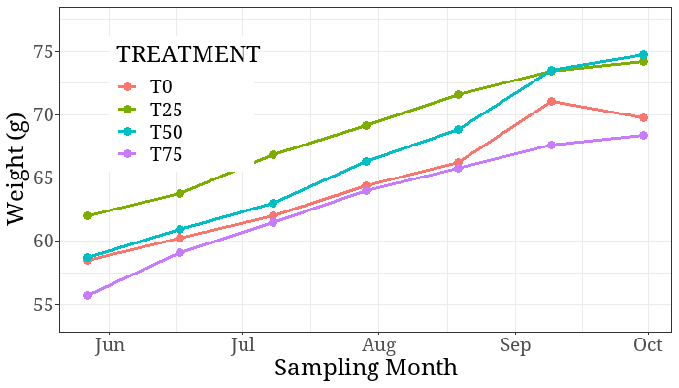

The length increment indicated that T25 showed the best length increment over the sampling period. T50 followed closely while T0 and T75 recorded the least progressive length increase over the research period.

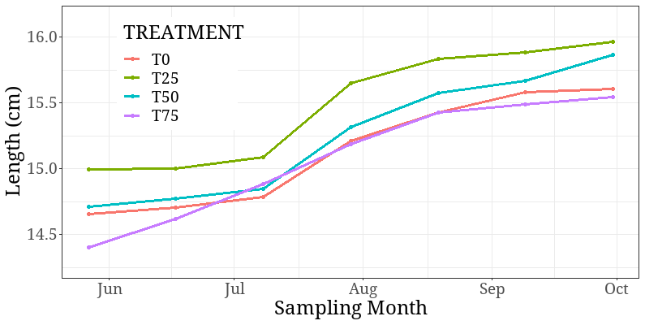

**Significance of Weight Variations Across the Research Period**

The analysis of variance (ANOVA) of weight and length over the treatments indicated that the mean differences in weight and length were statistically significant as expressed by probability values <0.001.

| **Variable** | **T0**, N = 587*1* | **T25**, N = 620*1* | **T50**, N = 625*1* | **T75**, N = 621*1* | **p-value***2* |
| --- | --- | --- | --- | --- | --- |
| WEIGHT | 64 ± 20 | 69 ± 19 | 67 ± 20 | 63 ± 18 | <0.001 |
| LENGTH | 15.11 ± 1.54 | 15.48 ± 1.43 | 15.25 ± 1.42 | 15.07 ± 1.49 | <0.001 |

A post hoc analysis of the ANOVA was carried out to determine which treatments were statistically significant which ones were not. The analysis indicated that T50 and T0 had statistically insignificant mean difference in weight as wells as T75 and T0 and T50 and T25. The only significant mean differences in weight were observed between T25 and T0, T75 and T25, T75 and T50.

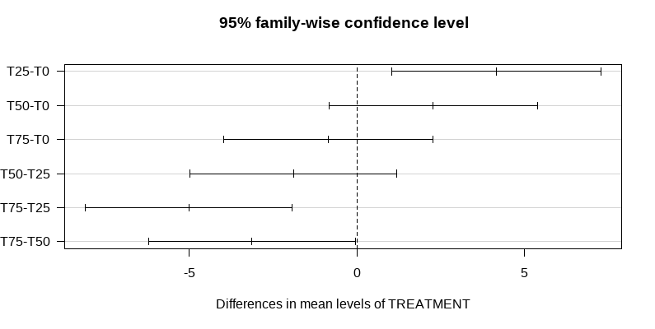

The mean differences in length were statistically significant between T25 & T0, T50 & T25, T75 & T50. The mean differences in length were statistically insignificant between T50 & T0, T75 & T0, T75 & T50. 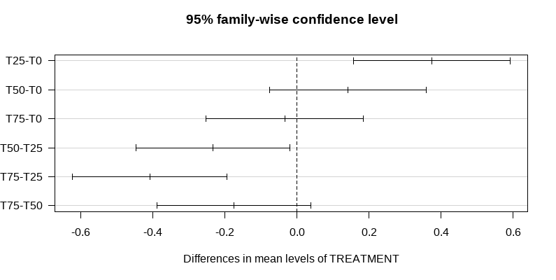

**Length Weight Relationship**

The length weight relationship is given by the equation $W=aL^{b}$ which can be expressed as $logW = loga + blogL$. The length-weight relationship among fish helps in determining the type of growth and exhibited by the fish. The growth can either be isometric or allometric. An Isometric type of growth, refers to increase in body length and girth at the same rate or proportion. Isometric growth is considered when the Length coefficient of growth is equal to 3. When that coefficient is greater than 3, the growth is referred to as positive allometric growth while when the length coefficient is less than 3 the growth is considered to be negative allometric growth. Allometric growth is referred when the elongation of the body trunk exceeds that of the body girth or vice versa.

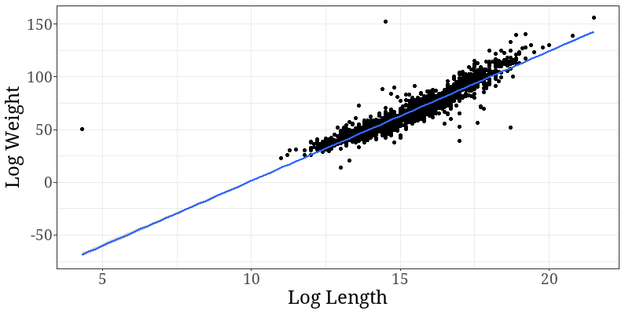

The coefficient or estimate of length as described by the analysis below is 2.89950. This estimate is less than 3 and thus the fish can be said to exhibit a negative allometric type of growth.

**Condition Factor**

The condition factor of fish is computed using the equation; $K=\frac{W}{L^{3}}$. A condition factor above 1 is considered acceptable. Treatment T50 exhibited the highest condition factor (K), while treatment T75 exhibited the lowest condition factor.

| TREATMENT | Condition Factor |
| --- | --- |
| T0 | 1.815454 |
| T25 | 1.807793 |
| T50 | 1.833108 |
| T75 | 1.893578 |

**Fish Growth Parameters**

Fish growth performance is determined through several concepts, terminologies and computations as discussed below. Firstly, there is final and initial weight which are used to determine weight gain or absolute growth for both weight and length. Daily weight gain follows which is also referred to as Relative growth rate which is the weight gain divided by the research period. Instantaneous growth rate is computed by taking weight gain and then dividing it by initial weight and then multiplied by 100. the formulars are as illustrated.

Absolute growth $Dw = wt-wi$

Absolute growth rate $AGR =\frac{wt – w}{t}$

Relative Growth Rate $RGR =\frac{wt – wi}{wi}* 100$

Instantaneous Growth rate $IGR =\frac{logwt – logwi}{t}$

Specific Growth Rate $SGR = logwt –\frac{logwi}{t}*100$

Feed Conversion Ratio $FCR = Feed\frac{intake}{weight}gain$

The growth parameters are illustrated in the table below; both for weight and length. The significance test indicate that there was no significant difference of growth parameters between treatments.

| **Growth Parameter** | **T0** | **T25** | **T50** | **T75** | **p-value***2* |
| --- | --- | --- | --- | --- | --- |
| Initial weight | 55 ± 16 | 62 ± 17 | 59 ± 16 | 56 ± 16 | 0.023 |
| Final weight | 70 ± 23 | 74 ± 23 | 75 ± 24 | 68 ± 19 | 0.2 |
| Absolute growth | 15 ± 28 | 12 ± 25 | 16 ± 26 | 13 ± 23 | 0.8 |
| Absolute growth rate | 0.09 ± 0.18 | 0.08 ± 0.16 | 0.10 ± 0.16 | 0.08 ± 0.14 | 0.8 |
| Relative growth rate | 38 ± 65 | 26 ± 47 | 34 ± 49 | 31 ± 45 | 0.5 |
| Instantaneous growth rate | 0.0014 ± 0.0027 | 0.0010 ± 0.0022 | 0.0014 ± 0.0022 | 0.0013 ± 0.0022 | 0.7 |
| Specific growth rate | 0.14 ± 0.27 | 0.10 ± 0.22 | 0.14 ± 0.22 | 0.13 ± 0.22 | 0.7 |
| Feed conversion ratio | 548 ± 11,479 | 13,432 ± 84,370 | 894 ± 11,575 | 1,191 ± 10,222 | 0.13 |

| **Growth Parameter** | **T0**, N = 59*1* | **T25**, N = 88*1* | **T50**, N = 89*1* | **T75**, N = 87*1* | **p-value***2* |
| --- | --- | --- | --- | --- | --- |
| Initial length | 14.36 ± 1.36 | 15.02 ± 1.19 | 14.73 ± 1.24 | 14.40 ± 1.33 | 0.003 |
| Final length | 15.60 ± 1.72 | 15.97 ± 1.65 | 15.87 ± 1.65 | 15.55 ± 1.95 | 0.3 |
| Absolute length growth | 1.25 ± 2.15 | 0.95 ± 1.78 | 1.13 ± 1.77 | 1.15 ± 2.16 | 0.8 |
| Absolute length growth rate | 0.008 ± 0.013 | 0.006 ± 0.011 | 0.007 ± 0.011 | 0.007 ± 0.014 | 0.8 |
| Relative length growth rate | 10 ± 16 | 7 ± 12 | 8 ± 12 | 9 ± 15 | 0.6 |
| Instantaneous length growth rate | 0.0005 ± 0.0009 | 0.0004 ± 0.0007 | 0.0005 ± 0.0007 | 0.0004 ± 0.0011 | 0.8 |
| Specific length growth rate | 0.05 ± 0.09 | 0.04 ± 0.07 | 0.05 ± 0.07 | 0.04 ± 0.11 | 0.8 |

**Discussion**

A major concern in the aquaculture sector is the high dependency by farmers on fish meal and fish oil. The desirable goal is however to search for a more sustainable, cost effective and environmentally friendly ingredients. Searching for these alternatives is challenging as alternatives must provide required levels of essential components of feed to ensure fish health and welfare standards are adhered to. In comparison with other conventional feed commodities, insects have received attention much more due to their minimal impact on the environment. In particular, BSF larvae meal can meet the nutritional requirements of many terrestrial and aquatic animals, including fish (Katya et al.,2017) evaluated BSF larvae meal and reported that up to 28.4% can be replaced without compromising growth performance.

In the present study, diets named T25 (Treatment 25) exhibited the highest growth performance in the entire set of diets during the trial period. However, results indicate that at 95% confidence level, the mean length and weight over the sampling period were statistically significant, as indicated in table 1 and 2 above. A similar result is reported in table 3 on the significant difference on mean length and weight across treatments all registering a p-value of <0.001. The results in table 4 shows that the experimental Fish exhibited a negative allometric type of growth since the coefficient length estimate is less than 3.

The results on the fish performance progress as shown in table 5 above clearly indicates that treatments with BSF diets are doing equally well as treatments with FM diets on the growth of the fish. With the significant difference in T0 and T75 experimental diets across sampling period, it can be reported that the two have a relatively similar effect on the fish mean body weight as explained by cages 1,5, 9 and 4,8,12. This would mean that substituting the two diets alternatively while the quantities of other ingredients are at Ceteris paribus would give the same output. However, this substitution is more effective when we formulate the diets with equal proportions of substituted diet as seen T25 and T50 performance as indicated in table 3.

As represented in table 5 above cages closer to the outlet and distant from the inlet registered a higher performance contrary to cages closer to the inlet. Cages 9, 10, 11 and 12 exhibited a lower performance in all the treatments as opposed to other cages/series. The above reason could be argued that in the inlet, the water coming in may have contained some silt and may contain less dissolved oxygen thus the poor performance of the experimental fish in the cages justified. An excellent performance by the cages far from the inlet could be attributed to water having less silt, increased oxygen level sufficient for the fish. As observed during sampling, majority of the fish in the cages registering low performance rate were female - female fish generally have a slow growth and slow response to feeding as opposed to male fish, few mortalities registered in the cages due stress brought about by low oxygen level of water coming through the inlet, the presence of outliers observed during random sampling and the winter season experienced during the month of June, July and August also contributed to low feeding habits by the experimental fish thus the performance.

**CONCLUSION**

A major concern in the aquaculture sector is the dependency on FM and fish oil, and a desirable goal is to search for more sustainable, cost effective, and environmentally friendly ingredients. Searching for these alternatives is challenging as alternatives must provide required levels of essential amino acids and high nutrient and energy bioavailability to ensure adherence to the fish health and welfare standards. In comparison with other conventional feed commodities, insects have been receiving attention as candidate feed ingredients due to their minimal impact on the environment. In particular BSF larvae can meet the nutritional requirements of many aquatic animals.

The challenges facing aquaculture production in Kenya today lie in the identification of cost-effective fish feeds. To achieve long-term food and nutritional security, insects have been identified as a cost-effective, reliable and sustainable source of protein and other nutrients for food and feeds. BSFL has the highest market potential of insect species to be used as a protein source for feed. The results from this experiment will allow farmers to switch to a feed which will increase the gains made from fish farming and increase their profit. These results will also boost investor confidence in the fact that there will be demand for the product since there is a gain in substituting with existing feed.

**REFERENCES**

Bandara, T. (2018). Alternative feed ingredients in aquaculture: Opportunities and challenges. Journal of Entomology and Zoology Studies, 6(2), 3087-3094.

Barroso, F. G., de Haro, C., Sánchez-Muros, M.-J., Venegas, E., Martínez-Sánchez, A., & Pérez-Bañón, C. (2014). The potential of various insect species for use as food for fish. Aquaculture, 422, 193-201.

Charo-Karisa, H., Opiyo, M., Munguti, J., Marijani, E., & Nzayisenga, L. (2013). Cost-Benefit Analysis and Growth Effects of Pelleted and Unpelleted On-Farm Feed on African Catfish (Claries Gariepinus Burchell 1822) in Earthen Ponds. African Journal of Food, Agriculture, Nutrition and Development, 13(4), 8019-8033.

Dicke, M. (2018). Insects as feed and the Sustainable Development Goals. Journal of Insects as Food and Feed, 4(3), 147-156.

Ermolaev, E., Lalander, C., & Vinnerås, B. (2019). Greenhouse gas emissions from small-scale fly larvae composting with Hermetia illucens. Waste Management, 96, 65-74.

FAO (2010) FishStat fishery statistical collections: aquaculture production (1950–2008; released March 2010). Rome, Italy: Food and Agriculture Organization of the United Nations.

FAO (2013a). Low-Income Food-Deficit Countries (LIFDC) – List for 2012. Retrieved from http://www.fao.org/countryprofiles/lifdc/en.

Friend, R.F. and Funge-Smith, S.J. (2012). Focusing small-scale aquaculture an aquatic resource management on poverty alleviation. FAO Regional Office Asia and the Pacific, Bangkok Thailand. RAP Publication, 2002/17: 34.

Gasco, L., Acuti, G., Bani, P., Dalle Zotte, A., Danieli, P. P., De Angelis, A., . . . Piccolo, G. (2020). Insect and fish by-products as sustainable alternatives to conventional animal proteins in animal nutrition. Italian Journal of Animal Science, 19(1), 360-372.

Gasco, L., Stas, M., Schiavone, A., Rotolo, L., De Marco, M., Dabbou, S., . . . Katz, H. (2015). Use of black soldier fly (Hermetia illucens) meal in rainbow trout (Oncorhynchus mykiss) feeds. Paper presented at the Aquaculture Europe Meeting 2015 “Acquaculture, Nature and Society”.

Govorushko, S. (2019). Global status of insects as food and feed source: A review. Trends in Food Science & Technology, 91, 436-445.

Henry, M., Gasco, L., Piccolo, G., & Fountoulaki, E. (2015). Review on the use of insects in the diet of farmed fish: past and future. Animal Feed Science and Technology, 203, 1-22.

Madau, F. A., Arru, B., Furesi, R., & Pulina, P. (2020). Insect farming for feed and food production from a circular business model perspective. Sustainability, 12(13), 5418.

Makkar, H. (2017). Opinion paper: Food loss and waste to animal feed. animal, 11(7), 1093-1095.

Mertenat, A., Diener, S., & Zurbrügg, C. (2019). Black Soldier Fly biowaste treatment–Assessment of global warming potential. Waste Management, 84, 173-181.

Muin, H., Taufek, N., Kamarudin, M., & Razak, S. (2017). Growth performance, feed utilization and body composition of Nile tilapia, Oreochromis niloticus (Linnaeus, 1758) fed with different levels of black soldier fly, Hermetia illucens (Linnaeus, 1758) maggot meal diet. Iranian Journal of Fisheries Sciences, 16(2), 567-577.

Ngugi, C.C. and Manyala, J.O. (2004). Aquaculture extension services in Kenya. Available at: [http://www.fao.org/docrep/007/y5641e/y5641e09.htm#](http://www.fao.org/docrep/007/y5641e/y5641e09.htm).

Nyonje, B. M., Opiyo, M. A., Orina, P. S., Abwao, J., Wainaina, M., & Charo-Karisa, H. (2018). Current status of freshwater fish hatcheries, broodstock management and fingerling production in the Kenya aquaculture sector. Livest Res Rural Dev, 30, 1-8.

Sánchez-Muros, M.-J., Barroso, F. G., & Manzano-Agugliaro, F. (2014). Insect meal as renewable source of food for animal feeding: a review. Journal of Cleaner Production, 65, 16-27.

Sealey, W. M., Gaylord, T. G., Barrows, F. T., Tomberlin, J. K., McGuire, M. A., Ross, C., & St‐Hilaire, S. (2011). Sensory analysis of rainbow trout, Oncorhynchus mykiss, fed enriched black soldier fly prepupae, Hermetia illucens. Journal of the World Aquaculture Society, 42(1), 34-45.

Surendra, K., Olivier, R., Tomberlin, J. K., Jha, R., & Khanal, S. K. (2016). Bioconversion of organic wastes into biodiesel and animal feed via insect farming. Renewable energy, 98, 197-202.

Tschirner, M., & Kloas, W. (2017). Increasing the sustainability of aquaculture systems: Insects as alternative protein source for fish diets. GAIA-Ecological Perspectives for Science and Society, 26(4), 332-340

Katya K., Borsra M.Z.S., Ganesan D., Kuppusamy G., Herriman M.,Salter A., Ali S.A (2017). Efficacy of insect larval meal to replace fish meal in juvenile barramundi. Lates calcarifer reared in freshwater. Aquat. Res. 2017; 9:303-312.